PROSPECTIVE BIDDER INFORMATION PACKET
JUNE RESALE OF DELINQUENT PROPERTY
9:00 AM AT THE PAYNE COUNTY ADMINISTRATION
BUILDING, 3RD FLOOR CONFERENCE ROOM.
LEE DENNEY, PAYNE COUNTY TREASURER
PAYNE COUNTY TREASURER’S OFFICE
405-624-9411

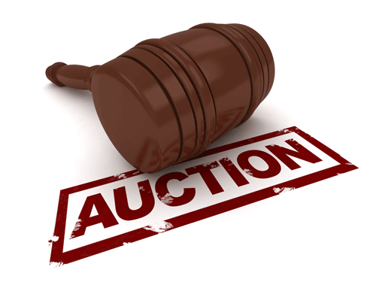

BEFORE THE SALE:
ALL RESALE BIDDERS MUST BE AT LEAST 18 YEARS OF AGE.
ALL INTERESTED PARTIES SHOULD DO THEIR OWN RESEARCH. ALL PROPERTIES ARE SOLD “AS IS”. THE PAYNE COUNTY TREASURER’S OFFICE HAS NO KNOWLEDGE OF THE PROPERTY, OTHER THAN THE INFORMATION THAT WE OBTAINED FROM THE TAX ROLLS, THE ASSESSOR’S OFFICE, AND THE COUNTY CLERK’S OFFICE.

UNDERSTAND THAT THIS IS A CASH-ONLY SALE. YOU MUST HAVE THE CASH ON HAND FOR YOUR BID. THE PROPERTY WILL BE SOLD TO THE HIGHEST BIDDER FOR CASH ONLY. PAYMENT FOR YOUR BIDS WILL BE EXPECTED AS SOON AS YOU ARE DECLARED THE HIGHEST SUCCESSFUL BIDDER ON EACH TRACT. THERE WILL ALSO BE A $30 FEE ATTACHED TO EACH PROPERTY SOLD. THIS FEE IS TO CREATE A DEED AND TO FILE THE DEED IN THE PAYNE COUNTY CLERKS OFFICE.
*** BIDDERS ARE NOT PERMITTED TO LEAVE THE PREMISES TO GET MONEY FOR THEIR BIDS AND RETURN AT A LATER TIME. ***

ONCE THE BIDDING PROCESS IS COMPLETE:
IF THE OKLAHOMA TAX COMMISSION (TW) OR THE IRS (FTL) HAS A LIEN, THOSE LIENS WILL STAY ATTACHED TO THE PROPERTY. YOU WILL NEED TO CONTACT EITHER ENTITY AND NEGOTIATE WITH THEM. IF SUCH A LIEN EXISTS, IT WILL BE ANNOUNCED BEFORE THE SALE AND WILL BE LISTED WITH THE PROPERTY ON THE RESALE TAX LIST.
IF THE PROPERTY HAS A MOBILE HOME THAT IS NOT INCLUDED WITH THE PROPERTY, IT WILL BE ANNOUNCED BEFORE THE SALE. THE BUYER WILL BE RESPONSIBLE FOR GIVING NOTICE TO THE MOBILE HOMEOWNER.

PLEASE NOTE THAT YOU DO NOT OWN THE PROPERTY UNTIL THE DEED IS FILED.

NOTA BENE: THIS IS A “BUYER BEWARE” SALE. THE RESPONSIBILITY TO PAY ANY AND ALL PROPERTY LIENS RESTS ON THE WINNING BIDDER.

RESEARCH THE PROPERTY IN WHICH YOU ARE INTERESTED.
TW (OKLAHOMA TAX LIENS) AND FTL’S (FEDERAL TAX LIENS) ARE NOT INCLUDED IN THE AMOUNT DUE, OR THE AMOUNT PAID AT THE RESALE AUCTION. YOU WILL HAVE TO CONTACT THE FEDERAL GOVERNMENT (FTL) AND THE STATE OF OKLAHOMA (TW) FOR FURTHER INFORMATION
ONCE THE BIDDING PROCESS IS COMPLETE, AND YOU HAVE PAID CASH FOR THE PROPERTY, YOU WILL RECEIVE A RECEIPT FOR YOUR PAYMENT, and the deed for the property will be filed and will be mailed within the week. THERE WILL ALSO BE A $30 FEE ATTACHED TO EACH PROPERTY SOLD. THIS FEE IS TO CREATE A DEED AND TO FILE THE DEED IN THE PAYNE COUNTY CLERK'S OFFICE.

