Understanding your tax bill

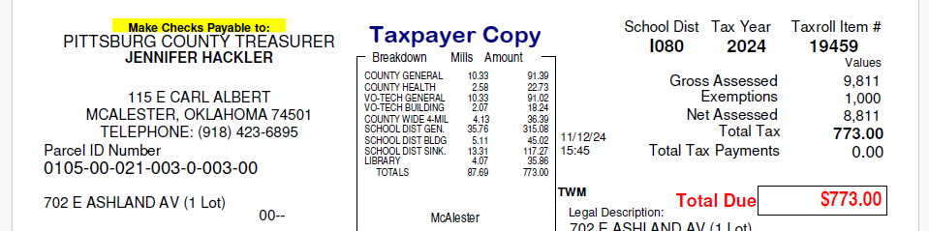



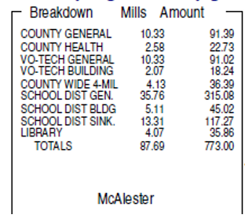

County General-Funding for courthouse utilities, upkeep, salaries, etc. County Health-Funding for Health Department Vo-Tech General-Funding for Vo-Tech general fund Vo-Tech Building-Funding for Vo-Tech building fund County Wide 4-Mill-Funding for schools School Dist. General- Funding for school district general fund School Dist. Building-Funding for school district building fund School Dist. Sinking-Funding for bond passed by school district County Library-Funding for county library

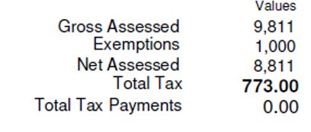 **Gross assessed**-11% of market value **Exemptions**-Homestead, double homestead and veteran’s exemption will show up here **Net Assessed**-Gross assessed minus exemptions. This is the amount you are taxed on. Take the net assessed and multiply the school district mills to get total tax due.

8811 x .08769= 772.64 (Total Bill $773.00)

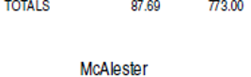

Where doe my property tax money go?

This Chart is based on McAlester’s School District, percentages may vary between school districts.

NO PROPERTY TAX MONEY GOES TO COUNTY ROADS